# Exercise – 1 : Setting Up JUnit

Step 1 : Create a new java Project in Intellij.

1. Open Intellij IDEA.
2. Click on File > New > Project.
3. Select Maven.
4. Then Click Next.

Step 2 : Add Junit Dependency.

1. Open pom.xml File.
2. Add Dependency in this file.

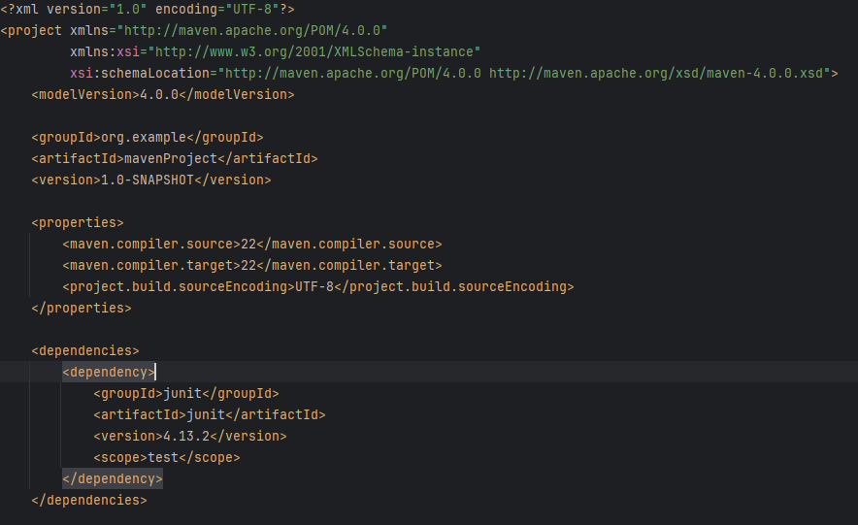

Step 3 : Create a New Test Class.

1. In src/test/java Create a java class named as “MyTest.java”.

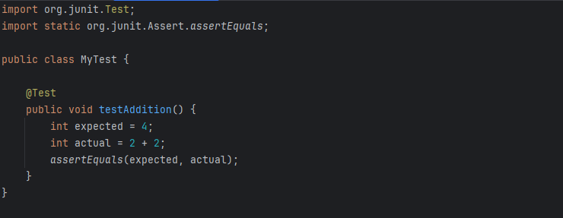

Output:

